TEST – 05

Name: T. Jithendra

Register Number: 192111521

Course Code: DSA0163

Course Name: Object Oriented

Programming with C++

Pointer to Integer:

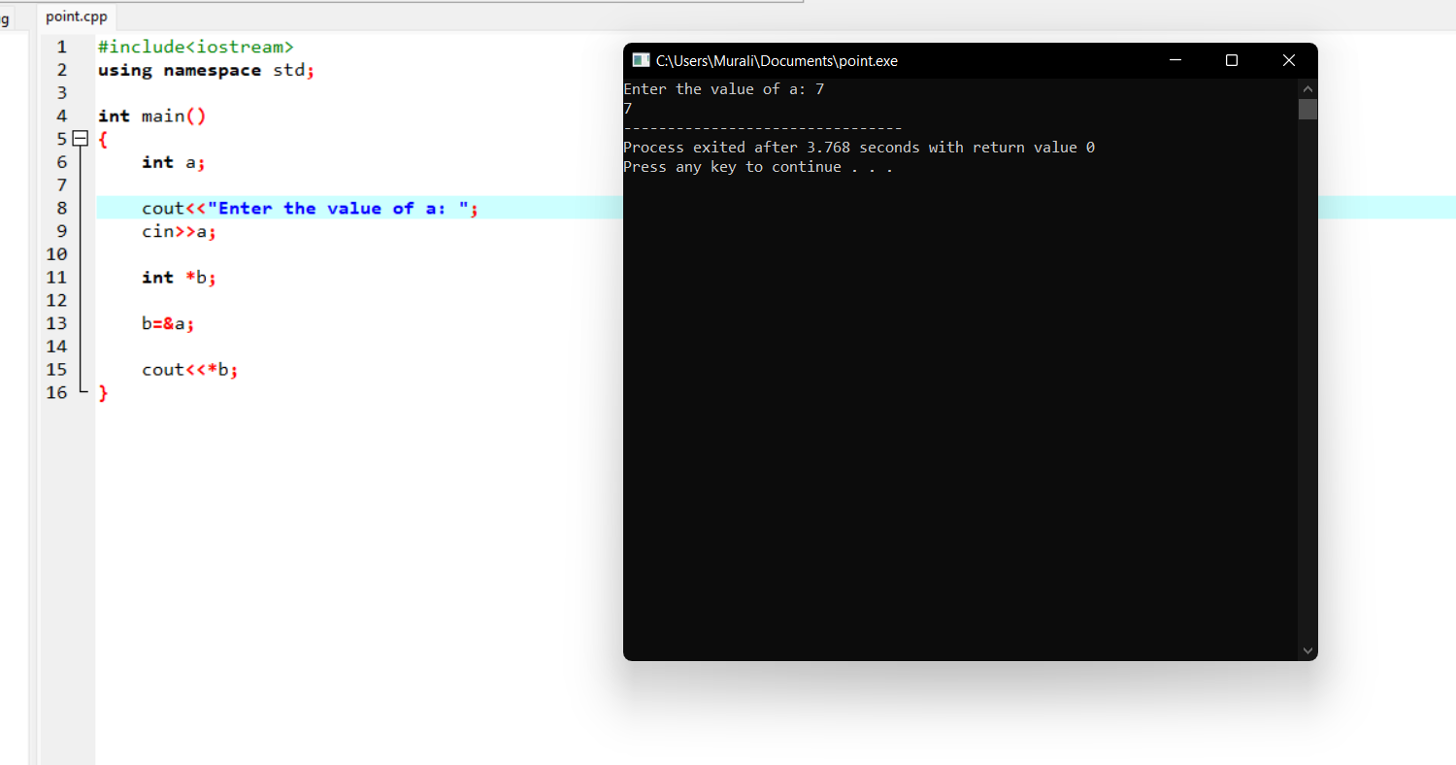

Pointer to character:

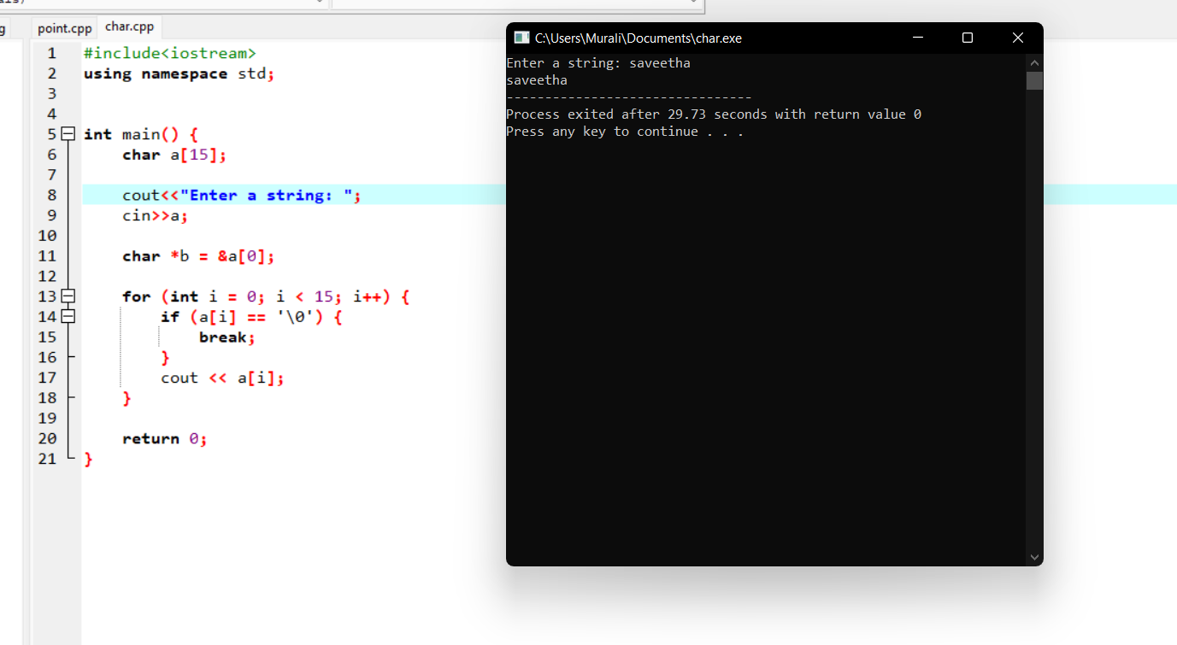

Pointer to float:

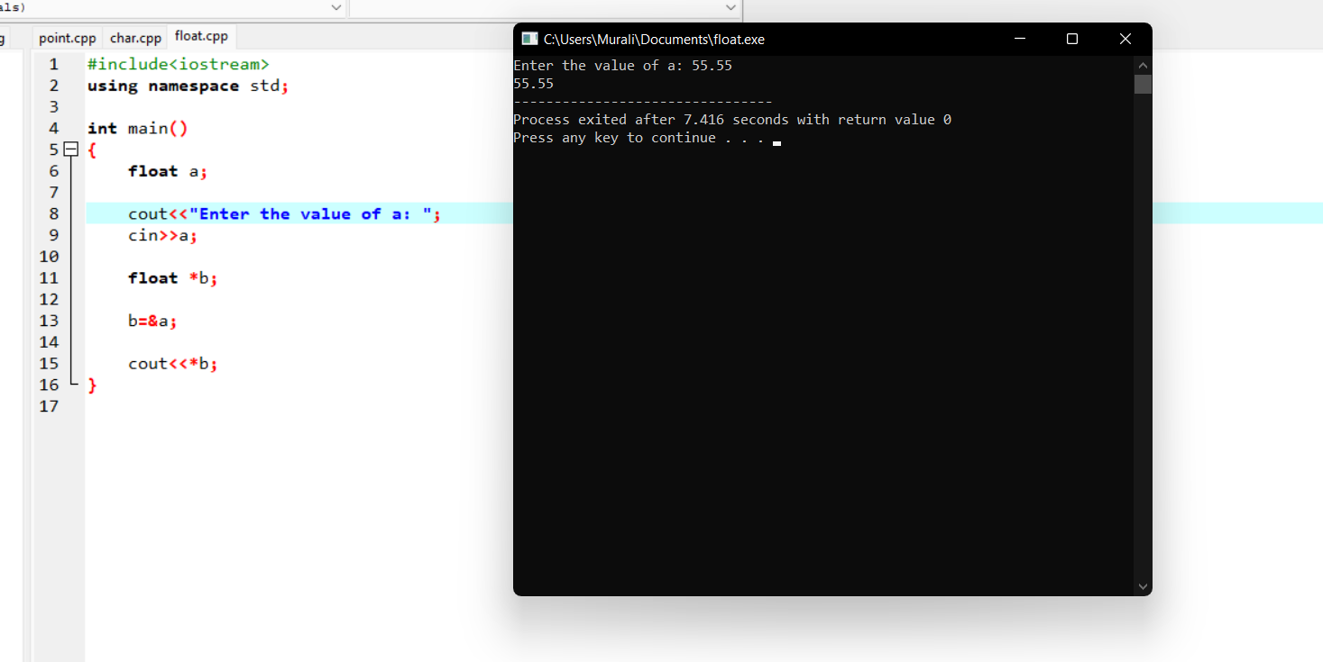

Pointer to object character:

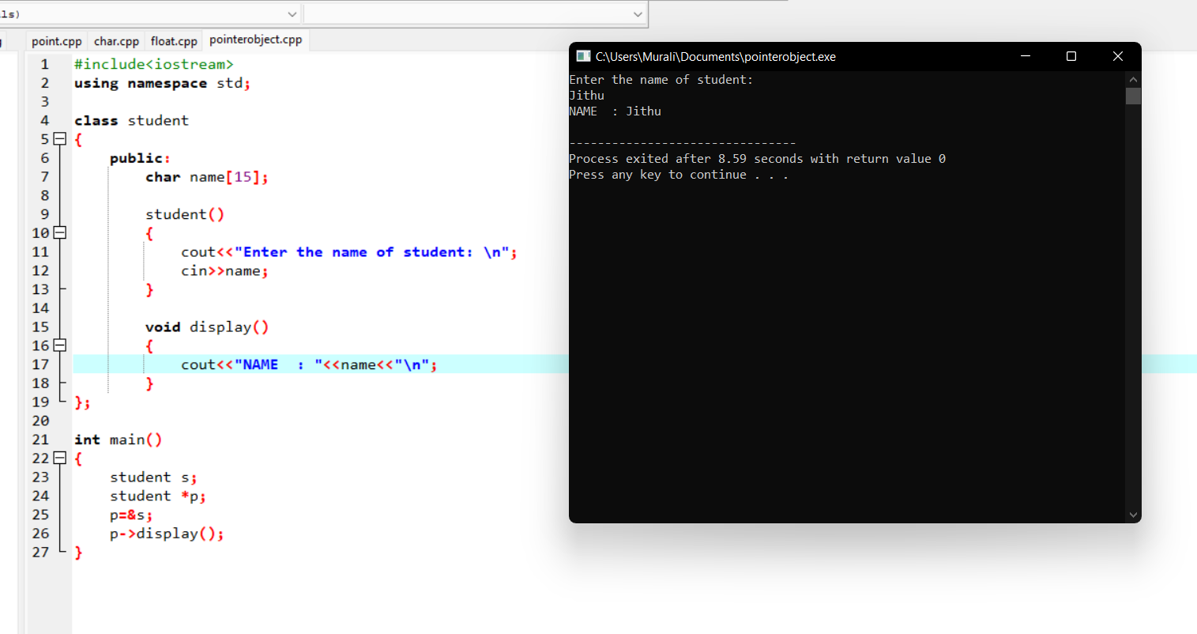

Pointer to object integer:

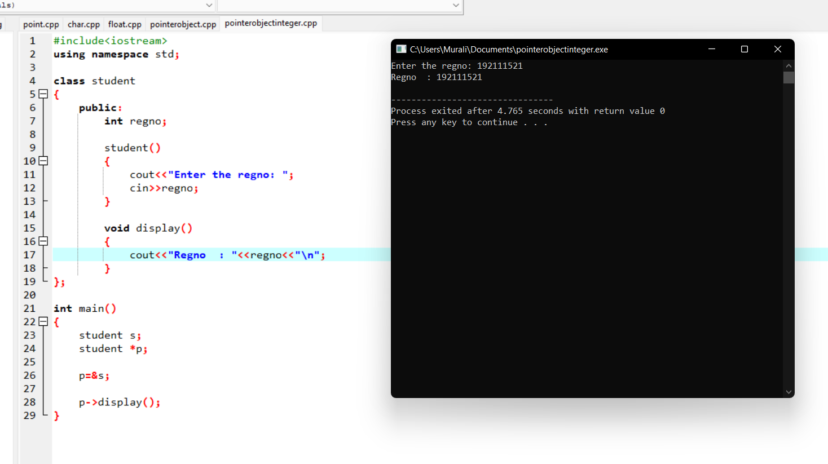

Pointer to object float:

